It is the 5th month since the start of the covid-19 pandemic. Just a few months ago, I was sitting in my living room, waiting out what seemed to be a particularly severe case of the flu. It was the start of March, and I’d just decided to take a week of vacation off. I’d gotten a haircut and was telling my haircutter about the visit to the African American museum we made as a company, as part of Black history month.

Little did I know that in the months since, this would be my last haircut (now more as a choice than a necessity). Unfortunately, as a re-migrant to the United States who was born here and grew up in India, I have a lot of friends and family in India who are coping with the pandemic differently. As we know, the US, as a resource rich and capital intensive country carries the resources and know how to not only diagnose and detect cases early, and to offer up expert safety measures, it also has the means to carry on working safely. Of course, the means to continue working safely vary within the US as well.

Today, however, we are going to focus on a rudimentary analysis of what can be said of the covid-19 cases across the world, on opposite sides of the globe. Doubtless, a lot of the response to the crisis has also been political. Since we tend to measure major events and time frames not only in decades, but also in presidencies and prime minister-ships, we cannot help but narrate the crisis against the backdrop of our current leaders.

Still, there are few key metrics that do not lie, and may help shed light on the current plight of the crisis as it stands, in the second week of July 2020.

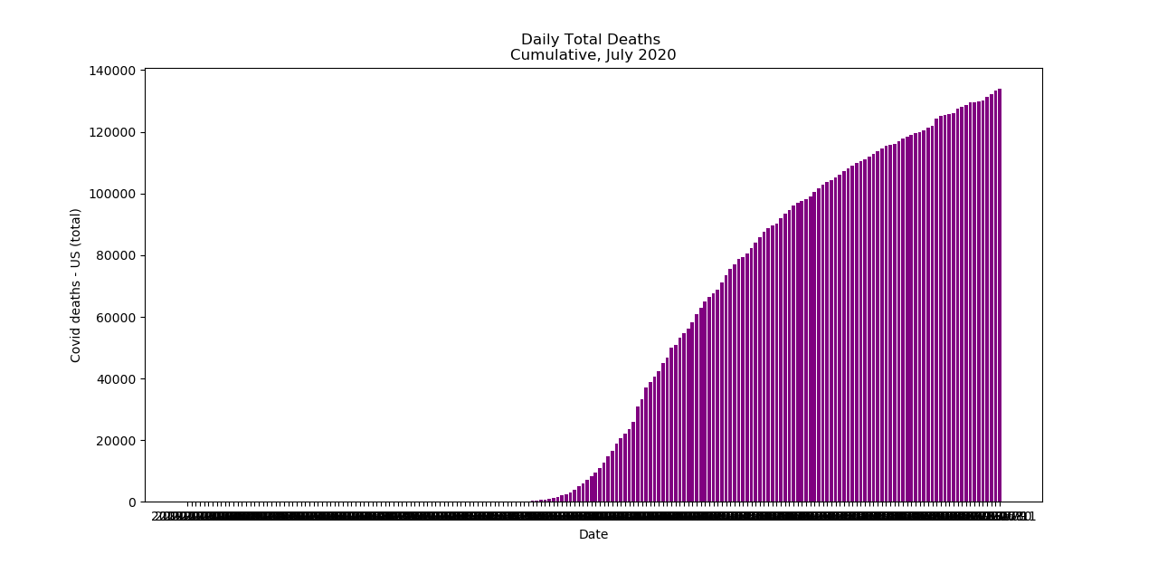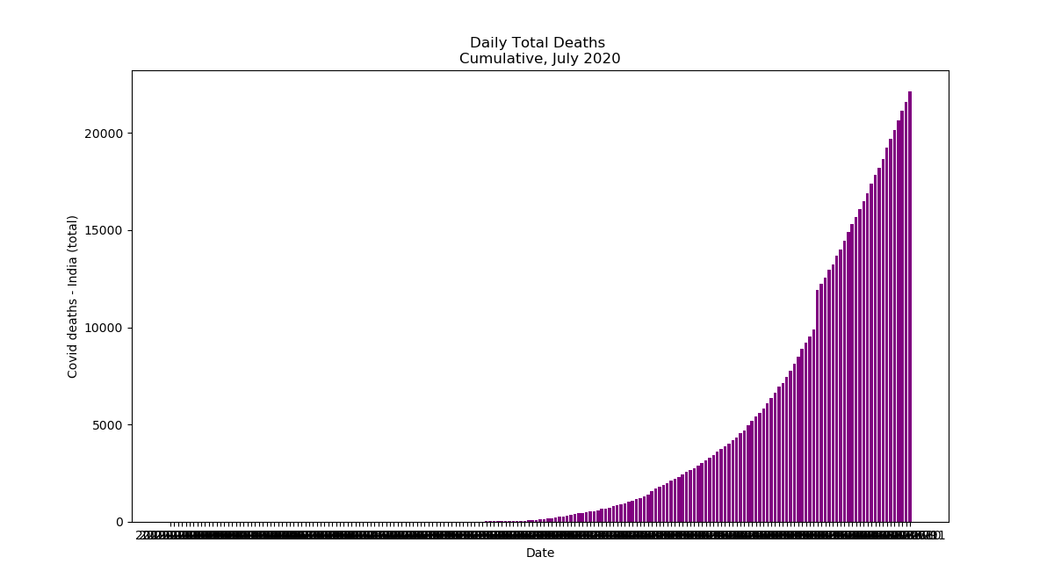

When stacked one on top of another, these graphs almost seem to show a complementary profile. Whereas the US is increasing at a decreasing rate, India’s numbers are increasing at an increasing rate. While the overall total counts for the US are far higher than that of India’s (almost 5-fold), the US’s growth in covid deaths seems to be tapering off. This is likely due to the concerted efforts the media has drawn attention to and encouraged in the recent past.